# Laboratory 5

Title of the Laboratory Exercise: HTML and JSP form to implement the functional requirement (Example: Login page and search page)

1. Introduction and Purpose of Experiment

Students will learn to use JSP scriplet, expression declaration and other JSP actions to

Implement different use cases

1. Aim and Objectives

Aim

Objectives

At the end of this lab, the student will be able to

1. Experimental Procedure
2. Calculations/Computations/Algorithms

login.jsp

<%@ page contentType = "text/html;charset=utf-8" %>

<html>

    <head>

    <title>Login</title>

    </head>

    <body *style*="text-align:center; margin:auto">

        <h1>Login to RUAS LMS</h1>

        <br/>

        <center>

            <form align="center" *action*="login" *method*="post">

                <table>

                    <tr>

                        <td>username</td>

                        <td><input *type*="text" *name*="username" /></td>

                    </tr>

                    <tr>

                        <td>password</td>

                        <td><input *type*="password" *name*="password" /></td>

                    </tr>

                </table>

                <br/>

                <input *type*="submit" *value*="login" />

            </form>

        </center>

    </body>

</html>

projects.jsp

<%@ page contentType = "text/html;charset=utf-8" %>

<html>

    <head>

    <title>Project</title>

    </head>

    <body *style*="text-align:center; margin:auto">

        <h1>Search for Project Details</h1>

        <br/>

        <center>

            <form align="center" *action*="search" *method*="get">

                <table>

                    <tr>

                        <td>usn no</td>

                        <td>

                            <input *type*="text" *name*="usnno" />

                        </td>

                    </tr>

                </table>

            </form>

        </center>

    </body>

</html>

1. Presentation of Results

Login Page

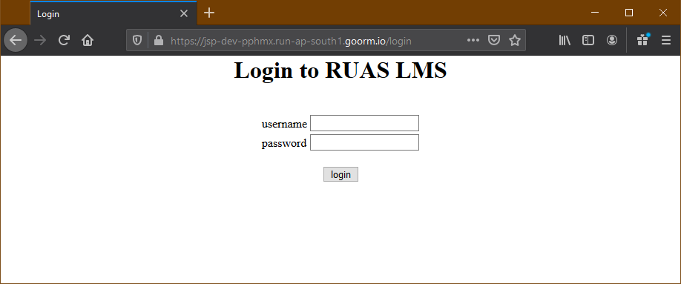

Search Page

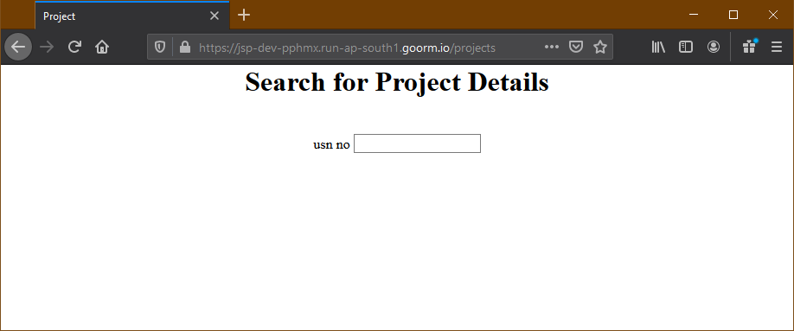

1. Analysis and Discussions

Java Server Pages (JSP) is a server-side programming technology that enables the creation of dynamic, platform-independent method for building Web-based applications. JSP have access to the entire family of Java APIs, including the JDBC API to access enterprise databases.

A JSP page is a text document that contains two types of text: static data, which can be expressed in any text-based format (such as HTML, SVG, WML and XML), and JSP elements, which construct dynamic content. It enables you to write dynamic, data-driven pages for your Java web applications. JSP is built on top of the Java Servlet specification. The two technologies typically work together, especially in older Java web applications. From a coding perspective, the most obvious difference between them is that with servlets you write Java code and then embed client-side markup (like HTML) into that code, whereas with JSP you start with the client-side script or markup, then embed JSP tags to connect your page to the Java backend.

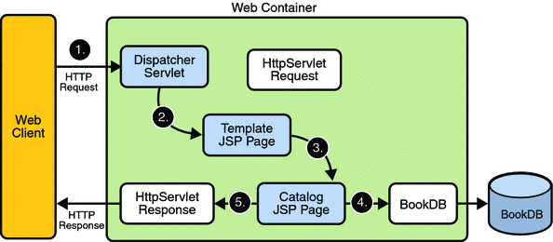

1. Conclusions

HTML is an essential but valuable skill. Beginners tend to neglect the importance of this language and this might be one of the biggest mistakes they commit in their formative years as developers. It is an easy to learn language and is responsible for building the structure of most websites you see on the world wide web. HTML is often perceived as a complex language but it’s really not.

JSP pages must be deployed inside a Java servlet container. In order to deploy a Java web application based on JSP and servlets, you will package your .jsp files, Java code, and application metadata in a .war file, which is a simple .zip file with a conventional structure for web applications.

1. Comments

a. Limitations of Experiments

Because JSP pages are translated, and then compiled into Java servlets, errors that creep in your pages are rarely seen as errors arising from the coding of JSP pages.

The JSP developer would need access to the generated source to properly diagnose the error. Of course, generated code is rarely a thing of beauty, and often, not easily understood.

Because JSP pages are translated into class files, the server has to store the resultant class files with the JSP pages.

b. Limitations of Results

None

c. Learning happened

We learnt how to crate login and search pages with JSP and HTML

d. Recommendations

None

|  |  |  |
| --- | --- | --- |
| **Component** | **Max Marks** | **Marks Obtained** |
| **Viva** | **6** |  |
| **Results** | **7** |  |
| **Documentation** | **7** |  |
| **Total** | **20** |  |